**1. INTRODUCTION:**

We have designed an ecommerce website named Fashionista. This website is built by us with a motive of providing ease to the shopkeepers who are facing difficulties now-a-days due to gradually increasing online shopping. Most of the shopkeepers faces difficulties in selling their products as people these days are not preferring to go to shops for purchasing; not even groceries. This ecommerce website is designed to fulfill their needs by giving them a online platform too by which it becomes easy for them to sell their products as well as to adapt technology.

E-commerce shops have become part of our daily lives. Technological advancement has made it possible for people to sit in the convenience of their homes and still shop online without going to a physical shop. This website is a general B2C e-commerce online store where people or shopkeepers can sell any product of their choice, we for now have put some clothes in our database which can be changed further. This project is mainly divided into two main categories:

The Administrators and the Customers/Users.

The store manager and the staff members operate as the administrators. They can add, edit, update products or, delete products thus they able to change the names of products, change prices and, add or remove products.

The customer can search for products selection, update the cart, remove products from the cart and check out from the shop. The customer is also able to update his information such as names, address and other data. The User is only able to browse the online shop and add a product to the cart. The user is limited to the use of the shop.

**2. TOOLS AND TECHNOLOGIES**

These are the necessary tools and materials needed to build the website both the frontend and the back-end. These include software and open-source materials.

**2.1. Html/Html5**

HTML means Hypertext Markup Language. This language is used in creating web pages. This language also supports other languages such CSS, PHP, JAVASCRIPT, etc. in creating interactive and responsive pages on the pages. HTML5 is just an updated version of the HTML. It supports new features, new attributes, new HTML elements, full CSS3 support, video and audio, 2D/3D graphics that help users and also help web developers to create new features easily on the website. There are several other versions too:

Basic structure of html:

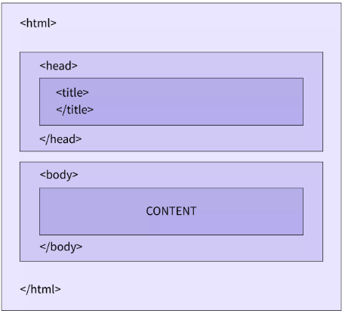

**2.2. CSS (Cascading Style Sheets)**

Cascading Style Sheets, fondly referred to as CSS, is a simply designed language intended to simplify the process of making web pages presentable. CSS allows you to apply styles to web pages. More importantly, CSS enables you to do this independent of the HTML that makes up each web page. It describes how a webpage should look: it prescribes colors, fonts, spacing, and much more. In short, you can make your website look however you want. CSS lets developers and designers define how it behaves, including how elements are positioned in the browser.

CSS selectors are used to “find” (or select) HTML elements based on their element name, id, class, attribute, and more.

**2.3. Bootstrap**

Bootstrap is a free and open-source tool collection for creating responsive websites and web applications. It is the most popular HTML, CSS, and JavaScript framework for developing responsive, mobile-first websites. Nowadays, the websites are perfect for all browsers (IE, Firefox, and Chrome) and for all sizes of screens (Desktop, Tablets, Phablets, and Phones).

**2.4. PHP**

The term PHP is an acronym for PHP: Hypertext Preprocessor. PHP is a server-side scripting language designed specifically for web development. It is open-source which means it is free to download and use. It is very simple to learn and use. The files have the extension “.php”.

Rasmus Leadoff inspired the first version of PHP and participated in the later versions. It is an interpreted language and it does not require a compiler.

Syntax:

<?php

PHP code goes here

?>

PHP can actually do anything related to server-side scripting or more popularly known as the backend of a website. For example, PHP can receive data from forms, generate dynamic page content, can work with databases, create sessions, send and receive cookies, send emails, etc. There are also many hash functions available in PHP to encrypt users’ data which makes PHP secure and reliable to be used as a server-side scripting language. So, these are some of PHP’s abilities that make it suitable to be used as a server-side scripting language.

**Characteristics of PHP are as follows:**

• Simple and fast

• Efficient

• Secured

• Flexible

• Cross-platform, it works with major operating systems like Windows, Linux, and macOS.

• Open Source

• Powerful Library Support

• Database Connectivity

**2.5. SQL**

SQL is Structured Query Language, which is a computer language for storing, manipulating and retrieving data stored in a relational database. SQL is the standard language for Relational Database System. All the Relational Database Management Systems (RDMS) like MySQL, MS Access, Oracle, Sybase, Informix, Postgres and SQL Server use SQL as their standard database language.

**DATABASE**

Databases are the storehouses of data used in the software systems. The data is stored in tables inside the database. Several tables are created for the manipulation of the data for the system. Two essential settings for a database are:

**Primary key**- the field that is unique for all the record occurrences.

**Foreign key**- the field used to set relation between tables.

**2.6. Xampp**

XAMPP is an abbreviation where X stands for Cross-Platform, A stands for Apache, M stands for MYSQL, and the Ps stand for PHP and Perl, respectively. It is an open-source package of web solutions that includes Apache distribution for many servers and command-line executables along with modules such as Apache server, MariaDB, PHP, and Perl.

XAMPP helps a local host or server to test its website and clients via computers and laptops before releasing it to the main server. It is a platform that furnishes a suitable environment to test and verify the working of projects based on Apache, Perl, MySQL database, and PHP through the system of the host itself.

**System Requirement:**

|  |  |
| --- | --- |
| System | Requirement |
| Operating system | Windows 11(or any other version) |
| Processor | Intel i3(or any upgraded version) |
| RAM | 512 MB (minimum), 1 GB (recommended) |

**3. SYSTEM STUDY**

**3.1. MODULES:**

The system after careful analysis has been identified to be presented with the following modules and roles.

* Administrator
* Users

**3.1.1. Administrator (Admin):**

The administrator is the super user of this application. Only admin have access into this admin page. Admin may be the owner of the shop.

The administrator has all the information about all the users and about all products. His functions:

**3.1.1.1. Add Products**

The shopping cart project contains different kind of products. The products can be classified into different categories by name. Admin can add new products into the existing system with all its details including an image.

**3.1.1.2. Delete Products**

Administrator can delete the products based on the stock of that particular product.

**3.1.2. USERS**

**3.1.2.1. Registration**

A new user will have to register in the system by providing essential details in order to view the products in the system. The admin must accept a new user by unblocking him.

**3.1.2.2. Login**

A user must login with his user’s name and password to the system after registration.

**3.1.2.3. View Products**

User can view the list of products based on their names after successful login. A detailed description of a particular product with product name, products details, product image, price can be viewed by users.

**3.1.2.4. Add to cart**

The user can add the desired product into his cart by clicking add to cart option on the product. He can view his cart by clicking on the cart button. All products added by cart can be viewed in the cart. User can remove an item from the cart by clicking remove.

**3.2. SYSTEM ANALYSIS**

System analysis is the process of gathering and interpreting facts, diagnosing problems and using the information to recommend improvements on the system. System analysis is a problem-solving activity that requires intensive communication between the system users

and system developers.

System analysis or study is an important phase of any system development process. The system is viewed as a whole, the inputs are identified and the system is subjected to close study to identify the problem areas. The solutions are given as a proposal. The proposal is reviewed on user request and suitable changes are made. This loop ends as soon as the user is satisfied with the proposal.

**3.2.1. EXISTNING SYSTEM**

The current system for shopping is to visit the shop manually and from the available product choose the item customer want and buying the item by payment of the price of the item.

1. It is less user-friendly.

2. User must go to shop and select products.

3. It is difficult to identify the required product.

4. Description of the product limited.

5. It is a time-consuming process

6. Not in reach of distant users.

**3.2.2. PROPOSED SYSTEM**

In the proposed system customer need not go to the shop for buying the products. He can order the product he wish to buy through the application in his Smartphone. The shop owner will be admin of the system. Shop owner can appoint moderators who will help owner in managing the customers and product orders. The system also recommends a home delivery system for the purchased products.

**4. SYSTEM REQUIREMENT SPECIFICATION**

(GENERAL DESCRIPTION)

**4.1. Product Description:**

The system consists of two parts. A web application which can provide the online shopping service and an android application for the customer to access the web service from his Smartphone. Web application should be able to help the customer for selecting his item and to help the owner in managing the orders from the customers.

**4.2. Problem Statement:**

As online shopping became a trend nowadays the regular shops are losing their customers to online brands. Customers have effortless shopping experience and saving time through shopping online. For competing with those online brands , If shops are providing an online portal where their customers can shop through internet and get the products at their doors it will increase the number of customers.

**4.3. SYSTEM OBJECTIVES**

1. To provide an android application for online shopping of products in an existing shop.

2. To provide a online shopping web site for the same shop.

**4.4 NON-FUNCTIONAL REQUIREMENTS**

**4.4.1. EFFICIENCY REQUIREMENT**

When an online shopping cart android application implemented customer can purchase product in an efficient manner.

**4.4.2. RELIABILITY REQUIREMENT**

The system should provide a reliable environment to both customers and owner. All orders should be reaching at the admin without any errors.

**4.4.3. USABILITY REQUIREMENT**

The android application is designed for user friendly environment and ease of use.

**4.4.4. IMPLEMENTATION REQUIREMENT**

Implementation of the system using css and html in front end with jsp as back end and it will be used for database connectivity. And the database part is developed by MySQL. Responsive web designing is used for making the website compatible for any type of screen.

**4.4.5. DELIVERY REQUIREMENT**

The whole system is expected to be delivered in four months of time with a weekly evaluation by the project guide.

**4.5 FUNCTIONAL REQUIREMENTS**

**4.5.1. USER**

**4.5.1.1. USER LOGIN**

Description of feature

This feature used by the user and admin to login into system. A user must login with his username and password to the system after registration. If they are invalid, the user not allowed to enter the system.

* **Functional requirement**

- Username and password will be provided after user registration is confirmed.

- Password should be hidden from others while typing it in the field.

**4.5.1.2. REGISTER NEW USER**

Description of feature

A new user will have to register in the system by providing essential details in order to view the products in the system. The admin must accept a new user by unblocking him.

* **Functional requirement**

- System must be able to verify and validate information.

- The system must encrypt the password of the customer to provide security.

**4.5.1.3. PURCHASING AN ITEM**

Description of feature

The user can add the desired product into his cart by clicking add to cart option on the product. He can view his cart by clicking on the cart button. All products added by cart can be viewed in the cart. User can remove an item from the cart by clicking remove. After confirming the items in the cart, the user can submit the cart by providing a delivery address. On successful submitting the cart will become empty.

* Functional requirement

- System must ensure that, only a registered customer can purchase items.

**4.5.2. ADMIN**

**4.5.2.1. ADMIN LOGIN**

Description of feature

This feature used by the user and admin to login into system. A user must login with his username and password to the system after registration. If they are invalid, the user not allowed to enter the system.

**4.5.2.2. MANAGE USER**

Description of feature

The administrator can add user, delete user, view user and block user.

**4.5.2.3. MANAGE PRODUCTS**

Description of feature

The administrator can add product, delete product and view product.

z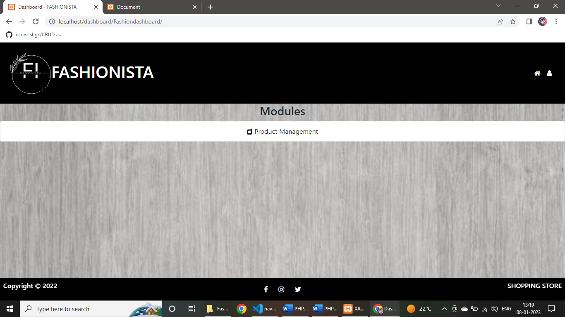

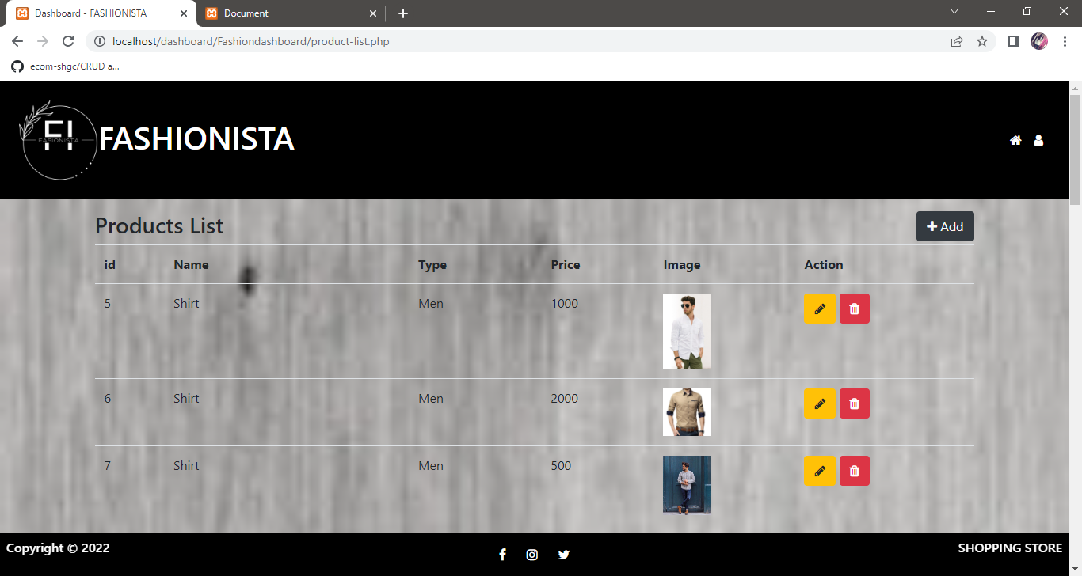

**4.5.2.4. MANAGE ORDER**

Description of feature

The administrator can view orders and delete orders.

* **Functional requirements**

-The system must identify the login of the admin.

-Admin account should be secured so that only owner of the shop can access that account.

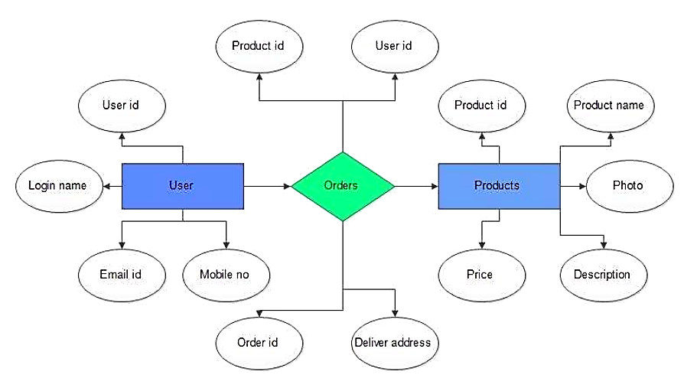**4.6 DIAGRAM:**

**5. Tables:**

**5.1. Registration table:**

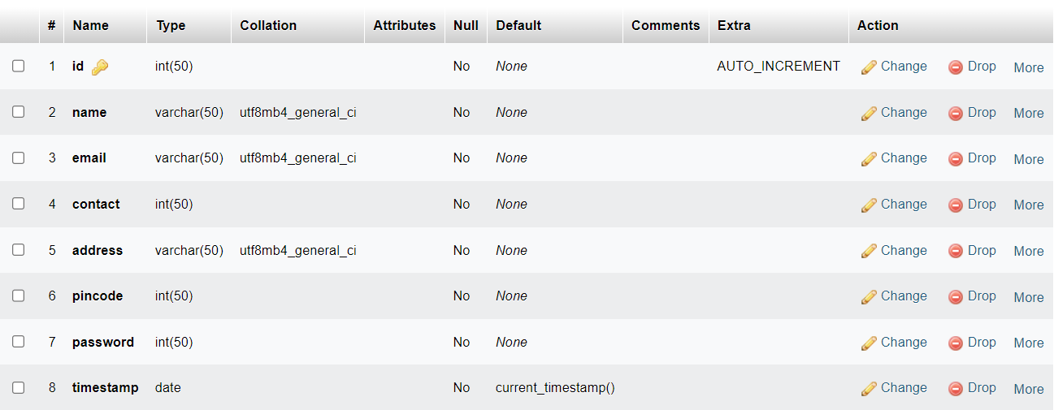

**5.2. Contact table:**

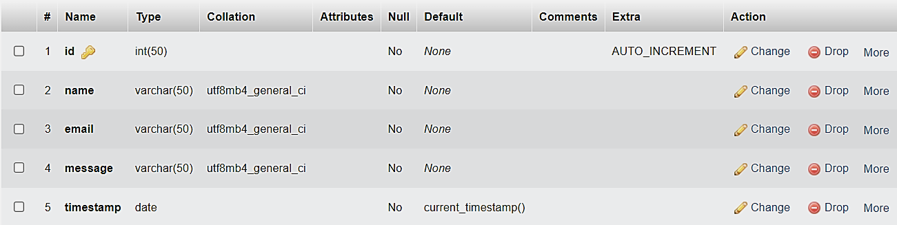

**5.3. Category table:**

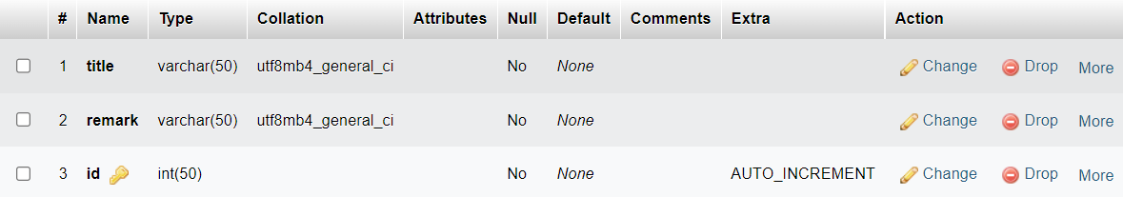

**5.4. Product table:**

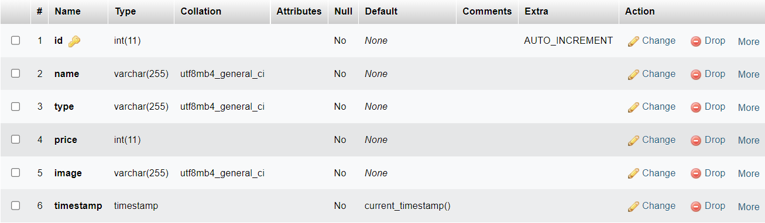

**6. Sample code and screenshots:**

* **Partials**
* **header.php**

<?php

if (!isset($pageName)) {

$pageName = 'HomePage';

}

$projectName = 'FASHIONISTA';

?>

<!DOCTYPE html>

<html lang="en">

<head>

<meta charset="UTF-8">

<meta http-equiv="X-UA-Compatible" content="IE=edge">

<meta name="viewport" content="width=device-width, initial-scale=1.0">

<title><?= $pageName ?> - <?php echo $projectName; ?></title>

<link rel="stylesheet" href="https://cdnjs.cloudflare.com/ajax/libs/font-awesome/4.7.0/css/font-awesome.min.css">

<link rel="stylesheet" href="https://maxcdn.bootstrapcdn.com/font-awesome/4.7.0/css/font-awesome.min.css">

<link rel="stylesheet" href="https://stackpath.bootstrapcdn.com/bootstrap/4.3.1/css/bootstrap.min.css" integrity="sha384-ggOyR0iXCbMQv3Xipma34MD+dH/1fQ784/j6cY/iJTQUOhcWr7x9JvoRxT2MZw1T" crossorigin="anonymous">

<link rel="stylesheet" href="css/style.css">

</head>

<body>

* **navbar.php**

<nav class="navbar navbar-expand-sm navbar text-white p-4" style="background-color:black;">

<img src="assets/images/logo.jpg" alt="img" width=100px>

<a class="navbar-brand text-white" href="home.php"><h1>FASHIONISTA</h1></a>

<button class="navbar-toggler d-lg-none" type="button" data-toggle="collapse" data-target="#collapsibleNavId" aria-controls="collapsibleNavId"

aria-expanded="false" aria-label="Toggle navigation">

<span class="navbar-toggler-icon"></span>

</button>

<div class="collapse navbar-collapse" id="collapsibleNavId">

<ul class="navbar-nav ml-auto mt-2 mt-lg-0">

<li class="nav-item active">

<a class="nav-link" href="home.php">

<i class="fa fa-home" aria-hidden="true"></i>

<span class="sr-only">(current)</span>

</a>

</li>

<li class="nav-item active">

<a class="nav-link" href="products.php">

Product

</a>

</li>

<li class="nav-item active">

<a class="nav-link" href="contactUs.php">

Contact Us

</a>

</li>

<li class="nav-item active">

<a class="nav-link" href="about.php">

About

</a>

</li>

<li class="nav-item active">

<a class="nav-link" href="login.php">

<i class="fa fa-user" aria-hidden="true"></i>

</a>

</li>

</ul>

</div>

</nav>

* **footer.php**

<!DOCTYPE html>

<html lang="en">

<head>

<meta charset="UTF-8">

<meta http-equiv="X-UA-Compatible" content="IE=edge">

<meta name="viewport" content="width=device-width, initial-scale=1.0">

<link rel="stylesheet" href="https://cdnjs.cloudflare.com/ajax/libs/font-awesome/6.2.0/css/all.min.css" integrity="sha512-xh6O/CkQoPOWDdYTDqeRdPCVd1SpvCA9XXcUnZS2FmJNp1coAFzvtCN9BmamE+4aHK8yyUHUSCcJHgXloTyT2A==" crossorigin="anonymous" referrerpolicy="no-referrer" />

</head>

<body>

<div id="footer" class="p-2 text-white" style="background-color:black;">

<div class="row">

<div class="col">

<h6> Copyright & copy 2022</h6>

</div>

<div class="col text-middle">

<div class="media-links">

<ul>

<li class="social-items"><a href=""><i class="fab fa-facebook-f"></i></a></li>

<li class="social-items"><a href=""><i class="fab fa-youtube"></i></a></li>

<li class="social-items"><a href=""><i class="fab fa-twitter"></i></a></li>

<li class="social-items"><a href=""><i class="fab fa-linkedin-in"></i></a></li>

<li class="social-items"><a href=""><i class="fab fa-instagram"></i></a></li>

</ul>

</div>

</div>

<div class="col text-right">

<h6>SHOPPING STORE</h6>

</div>

</div>

</div>

</body>

</html>

* **login.php**

<form action="scripts/loginProcess.php" method="POST" class="container pt-3">

<h2 class="text-center">Login Here...</h2>

<div class="form-group">

<label for="email"><b>Email</b></label>

<input type="email"

class="form-control" name="email" id="email" aria-describedby="emailhelpId" placeholder="Enter Email here">

<small id="emailhelpId" class="form-text text-dark">Enter Email here ...</small>

</div>

<div class="form-group">

<label for="password"><b>Password</b></label>

<input type="password"

class="form-control" name="password" id="password" aria-describedby="passwordhelpId" placeholder="Enter Password here">

<small id="passwordhelpId" class="form-text text-dark">Enter Password here ...</small>

</div>

<button type="reset" class="btn btn-danger">

RESET

</button>

<a class="click btn" href="dashboard.php">

<button type="submit" class="btn btn-primary">

LOGIN

</button>

</a>

<div>

<b> If you don't have account then click </b>

<a class="click btn" href="signup.php">

<button type="button" class="btn btn-info">

SIGN UP

</button>

</div>

</form>

* signUpForm.php

<form action="scripts/signUpProcess.php" method="POST" class="container pt-3">

<h2 class="text-center">Sign Up Here..</h2>

<div class="form-group">

<label for="name"><b>Name</b></label>

<input type="text"

class="form-control" name="name" id="name" aria-describedby="namehelpId" placeholder="Enter Full Name">

<small id="namehelpId" class="form-text text-dark">Enter Full Name here ...</small>

</div>

<div class="form-group">

<label for="email"><b>Email</b></label>

<input type="email"

class="form-control" name="email" id="email" aria-describedby="emailhelpId" placeholder="Enter Email here">

<small id="emailhelpId" class="form-text text-dark">Enter Email here ...</small>

</div>

<div class="form-group">

<label for="contact"><b>Contact</b></label>

<input type="number"

class="form-control" name="contact" id="contact" aria-describedby="contacthelpId" placeholder="Enter Contact here">

<small id="contacthelpId" class="form-text text-dark">Enter Contact here ...</small>

</div>

<div class="form-group">

<label for="address"><b>Address</b></label>

<input type="text"

class="form-control" name="address" id="address" aria-describedby="addresshelpId" placeholder="Enter Address here">

<small id="addresshelpId" class="form-text text-dark">Enter Address here ...</small>

</div>

<div class="form-group">

<label for="pincode"><b>Pincode</b></label>

<input type="number"

class="form-control" name="pincode" id="pincode" aria-describedby="pincodehelpId" placeholder="Enter Pincode here">

<small id="pincodehelpId" class="form-text text-dark">Enter Pincode here ...</small>

</div>

<div class="form-group">

<label for="password"><b>Password</b></label>

<input type="password"

class="form-control" name="password" id="password" aria-describedby="passwordhelpId" placeholder="Enter Password here">

<small id="passwordhelpId" class="form-text text-dark">Enter Password here ...</small>

</div>

<button type="reset" class="btn btn-danger">

Reset

</button>

<button type="submit" class="btn btn-primary">

Submit

</button>

</form>

* **contact.php**

<form action="scripts/contactProcess.php" method="POST" class="container pt-3">

<h2 class="text-center">Contact Us...</h2>

<div class="form-group">

<label for="name"><b>Name</b></label>

<input type="text"

class="form-control" name="name" id="name" aria-describedby="namehelpId" placeholder="Enter Name here">

<small id="passwordhelpId" class="form-text text-dark">Enter Password here ...</small>

</div>

<div class="form-group">

<label for="email"><b>Email</b></label>

<input type="email"

class="form-control" name="email" id="email" aria-describedby="emailhelpId" placeholder="Enter Email here">

<small id="emailhelpId" class="form-text text-dark">Enter Email here ...</small>

</div>

<div class="form-group">

<label for="message"><b>Message</b></label>

<input type="text"

class="form-control" name="message" id="message" aria-describedby="passwordhelpId" placeholder="Enter Message here">

<small id="messagehelpId" class="form-text text-dark">Enter Message here ...</small>

</div>

<a class="click btn" href="home.php">

<button type="submit" class="btn btn-primary">

SUBMIT

</button>

</a>

<div>

</div>

</form>

* **allproducts.php(the whole product display window)**

<?php

include "config/db.php";

$category = $_GET['type'];

$sql = " SELECT * FROM `product` WHERE `type` = '$category'";

$res = mysqli_query($conn, $sql);

$pageName = "MEN'S PRODUCT";

include 'partials/header.php';

include 'partials/navbar.php';

?>

<div class="container">

<div class="text-center">

<h3>Product List</h3>

</div>

<div class="row">

<?php

while ($row = mysqli_fetch_assoc($res)) {

?>

<div class="col-4">

<div class="card">

<div class="card-header">

<h3><?= $row['name'] ?></h3>

</div>

<div class="card-body">

<img width="50%" height="100px" src="../uploads/<?= $row['image']?>" alt="mlksajfdslkfs" srcset="">

<p>

<b>Price = <?= $row['price'] ?>;</b>

</p>

<!-- <h3>

Category = <?= $row['type'] ?>

</h3> -->

<a class="click btn" href="buynow.php">

<button type="button" class="btn btn-warning">

BUY NOW

</button>

</a>

</div>

</div>

</div>

<?php

}

?>

</div>

</div>

<?php

include 'partials/footer.php';

include './config/db.php';

?>

* **scripts.php**

<!-- Scripts -->

<script src="https://code.jquery.com/jquery-3.3.1.slim.min.js" integrity="sha384-q8i/X+965DzO0rT7abK41JStQIAqVgRVzpbzo5smXKp4YfRvH+8abtTE1Pi6jizo" crossorigin="anonymous"></script>

<script src="https://cdnjs.cloudflare.com/ajax/libs/popper.js/1.14.7/umd/popper.min.js" integrity="sha384-UO2eT0CpHqdSJQ6hJty5KVphtPhzWj9WO1clHTMGa3JDZwrnQq4sF86dIHNDz0W1" crossorigin="anonymous"></script>

<script src="https://stackpath.bootstrapcdn.com/bootstrap/4.3.1/js/bootstrap.min.js" integrity="sha384-JjSmVgyd0p3pXB1rRibZUAYoIIy6OrQ6VrjIEaFf/nJGzIxFDsf4x0xIM+B07jRM" crossorigin="anonymous"></script>

</body>

</html>

* css/style.php

*{

font-family:sans-serif;

}

.logo{

width: 80px;

cursor: pointer;

padding: 5px;

}

/* img {

padding: 5px;

width: 100px;

} */

#footer {

position: fixed;

bottom: 0;

width: 100%;

}

body {

margin-bottom: 100px;

background-image: url("./../assets/images/bg2.jpg");

background-repeat: no-repeat;

background-size: cover;

font-family: Poppins, sans-serif;

font-size: 16px;

}

.navbar ul li{

list-style: none;

display: inline-block;

margin: 0 20px;

position: relative;

}

.navbar ul li a{

text-decoration: none;

color: #fff;

text-transform: uppercase;

}

.navbar ul li::after{

content: '';

height: 3px;

width: 0;

background: #fcfbfb;

position: absolute;

left: 0;

bottom: -10px;

transition: 0.5s;

}

.navbar ul li:hover::after{

width: 100%;

}

.content{

width: 100%;

position: absolute;

top: 50%;

transform: translateY(-50%);

text-align: center;

color: black;

}

.content h1{

font-size: 70px;

margin-top: 80px;

}

.content p{

margin: 20px auto;

font-weight: 100;

line-height: 25px;

}

a {

color: inherit !important;

}

button{

width: 200px;

padding: 15px 0;

text-align: center;

margin: 20px 10px;

border-radius: 25px;

font-weight: bold;

border: 2px solid black;

background: transparent;

color: black;

cursor: pointer;

position: relative;

overflow: hidden;

}

span{

background: hsla(180, 9%, 98%, 0.991);

height: 100%;

width: 0;

border-radius: 25px;

position: absolute;

left: 0;

bottom: 0;

z-index: -1;

transition: 0.5s;

}

button:hover span{

width: 100%;

}

button:hover{

border: none;

}

.row{

margin: 5px;

padding: 05px;

background-color:black ;

}

.media-links{

display:block;

}

.media-links ul{

padding: 10px;

display: flex;

width: 150px;

height: 10px;

margin: auto;

}

.social-items{

list-style: none;

}

.social-items a{

padding: 10px;

font-size: 20px;

color: #ddd;

transition: all 0.25s;

}

.social-items a:hover{

background-color:rgb(66, 66, 61);

width: 50%;

size: 50%;

}

* home.php

<!DOCTYPE html>

<html lang="en">

<head>

<meta charset="UTF-8">

<meta http-equiv="X-UA-Compatible" content="IE=edge">

<meta name="viewport" content="width=device-width, initial-scale=1.0">

<title>Document</title>

</head>

<body>

<div class="content text-black">

<h1>STYLE WITH TREND</h1>

<p>We are here with the trending collections ever. <br> Come along with and dress with style. </p>

<div>

<button type="button"> <a href="login.php"> <span></span> LOGIN</a></button>

<button type="button"><a href="products.php"><span></span>EXPLORE</a></button>

</div>

</div>

</body>

</html>

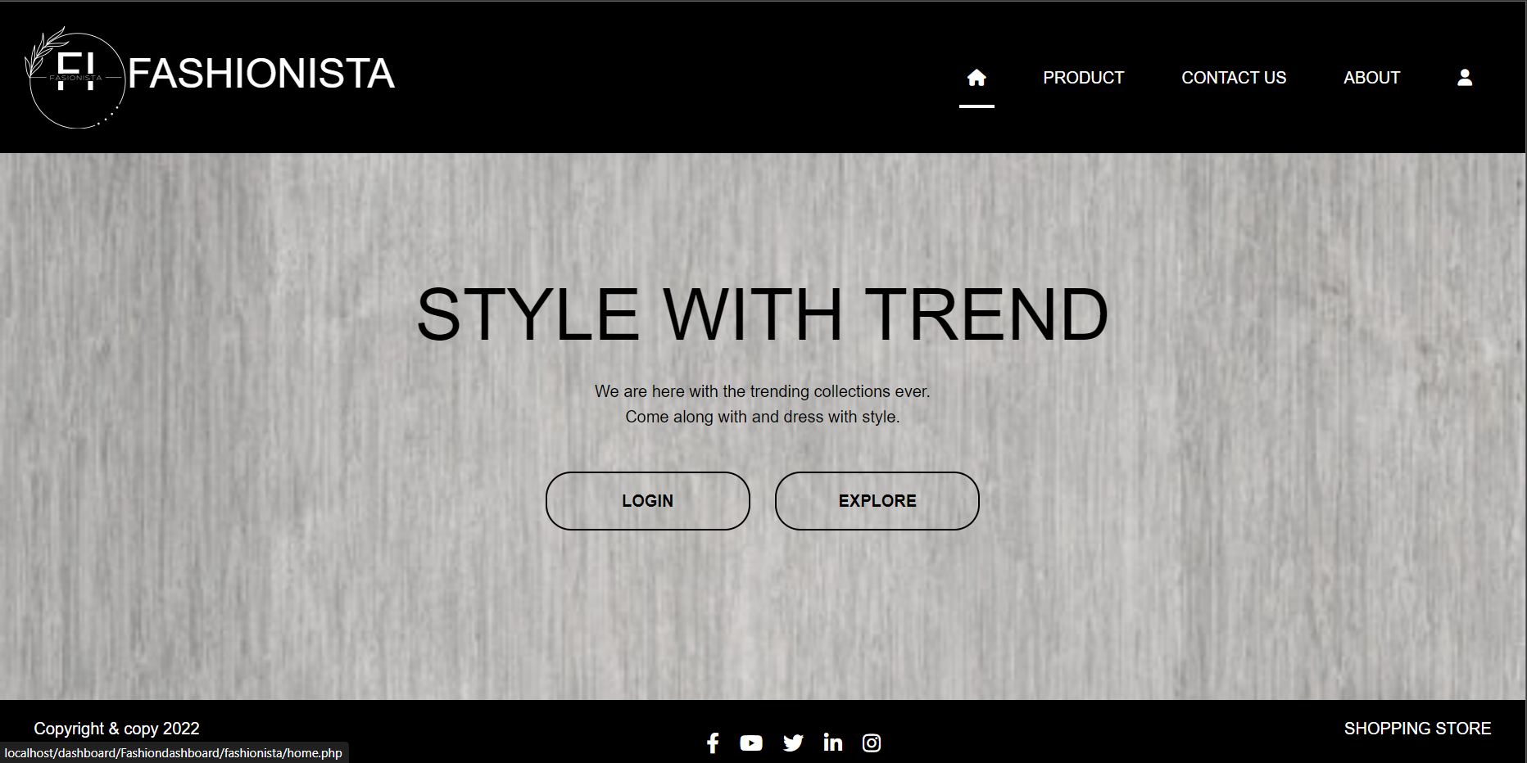

* login.php

<!-- Template Head Start -->

<?php

$pageName = 'Login Page';

include 'partials/header.php';

include 'partials/navbar.php';

?>

<!-- Template Head End -->

<!-- Page Body Start -->

<?php

include 'partials/loginForm.php';

?>

<!-- Page Body End -->

<!-- Template Body Start -->

<?php

include 'partials/footer.php';

include 'partials/scripts.php';

?>

<!-- Template Body End -->

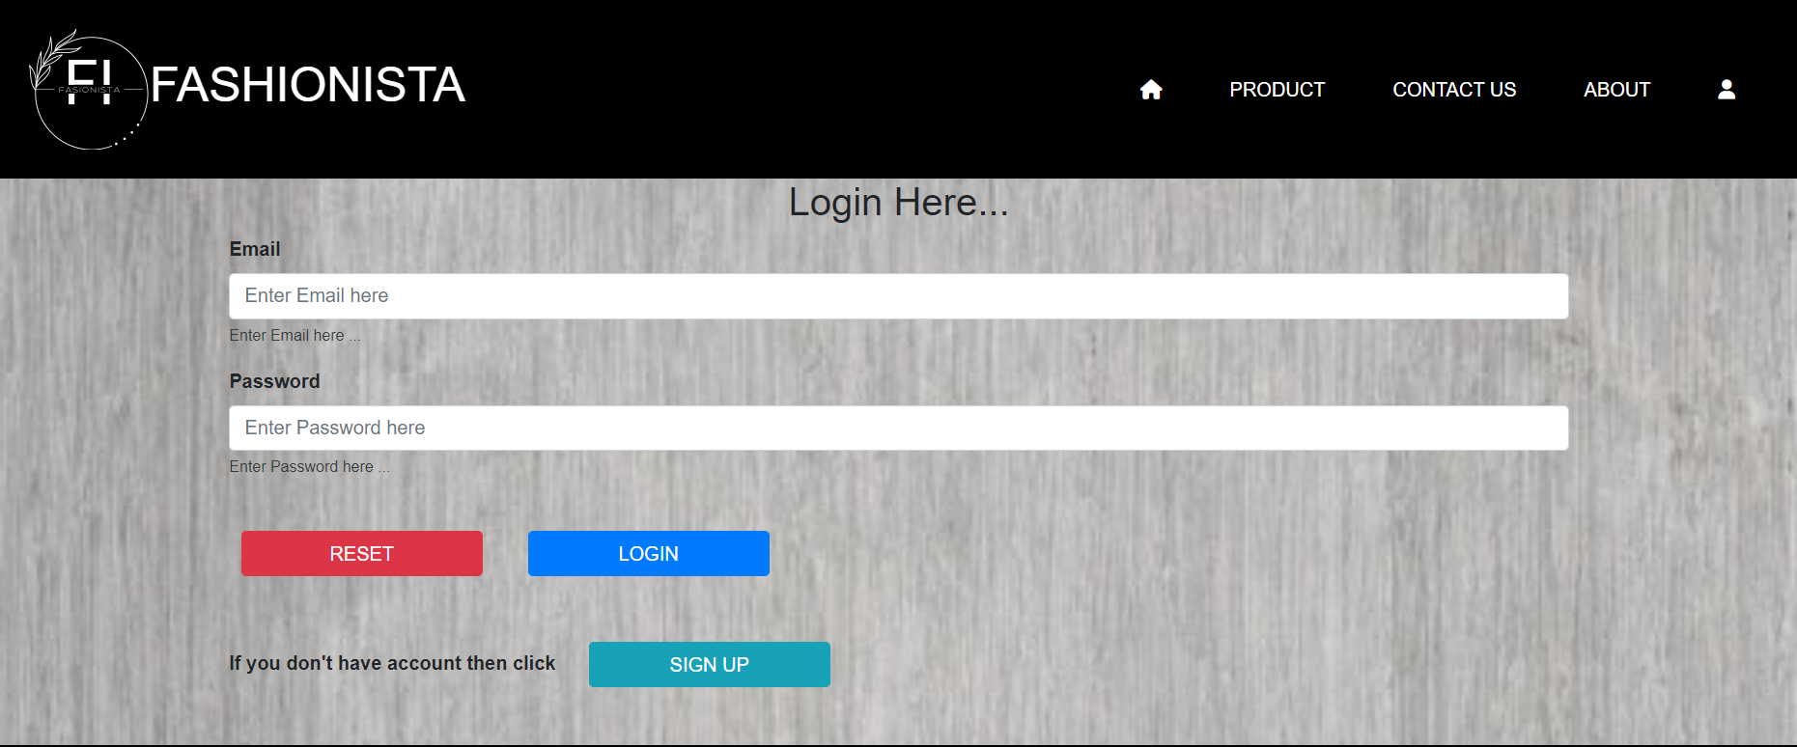

* signup.php

<!-- Template Head Start -->

<?php

$pageName = 'Sign Up Page';

include 'partials/header.php';

include 'partials/navbar.php';

?>

<!-- Template Head End -->

<!-- Page Body Start -->

<?php

include 'partials/signUpForm.php';

?>

<!-- Page Body End -->

<!-- Template Body Start -->

<?php

include 'partials/footer.php';

include 'partials/scripts.php';

?>

<!-- Template Body End -->

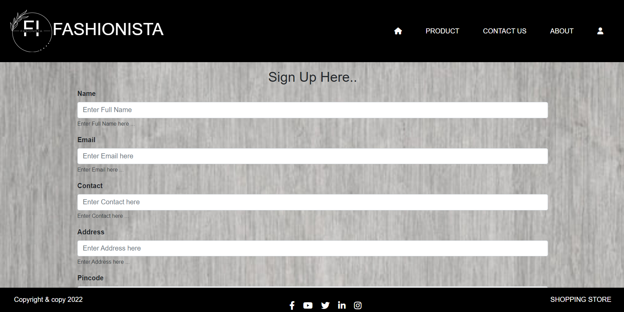

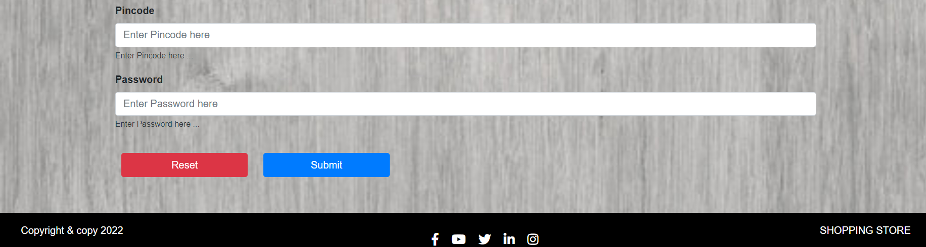

* modules.php

<br>

<h3 class="text-center"> TO SYTLE WITH TREND YOU SHOULD GO THROUGH OUR PRODUCTS </h3>

<br><br><br>

<div class="container">

<div class="row">

<div class="col-sm">

<div class="card" style="width: 18rem;">

<img src="assets/images/men.jpg" class="card-img-top" alt="...">

<div class="card-body">

<h5 class="card-title">MEN'S WEAR</h5>

<a href="allproduct.php?type=Men" class="btn btn-primary">CLICK</a>

</div>

</div>

</div>

<div class="col-sm">

<div class="card" style="width: 18rem;">

<img src="assets/images/women.jpg" class="card-img-top" alt="image to aai hai">

<div class="card-body">

<h5 class="card-title">WOMEN'S WEAR</h5>

<a href="allproduct.php?type=Women" class="btn btn-primary">CLICK</a>

</div>

</div>

</div>

<div class="col-sm">

<div class="card" style="width: 18rem;">

<img src="assets/images/kids.jpg" class="card-img-top" alt="...">

<div class="card-body">

<h5 class="card-title">KID'S WEAR</h5>

<a href="allproduct.php?type=Kids" class="btn btn-primary">CLICK</a>

</div>

</div>

</div>

</div>

</div>

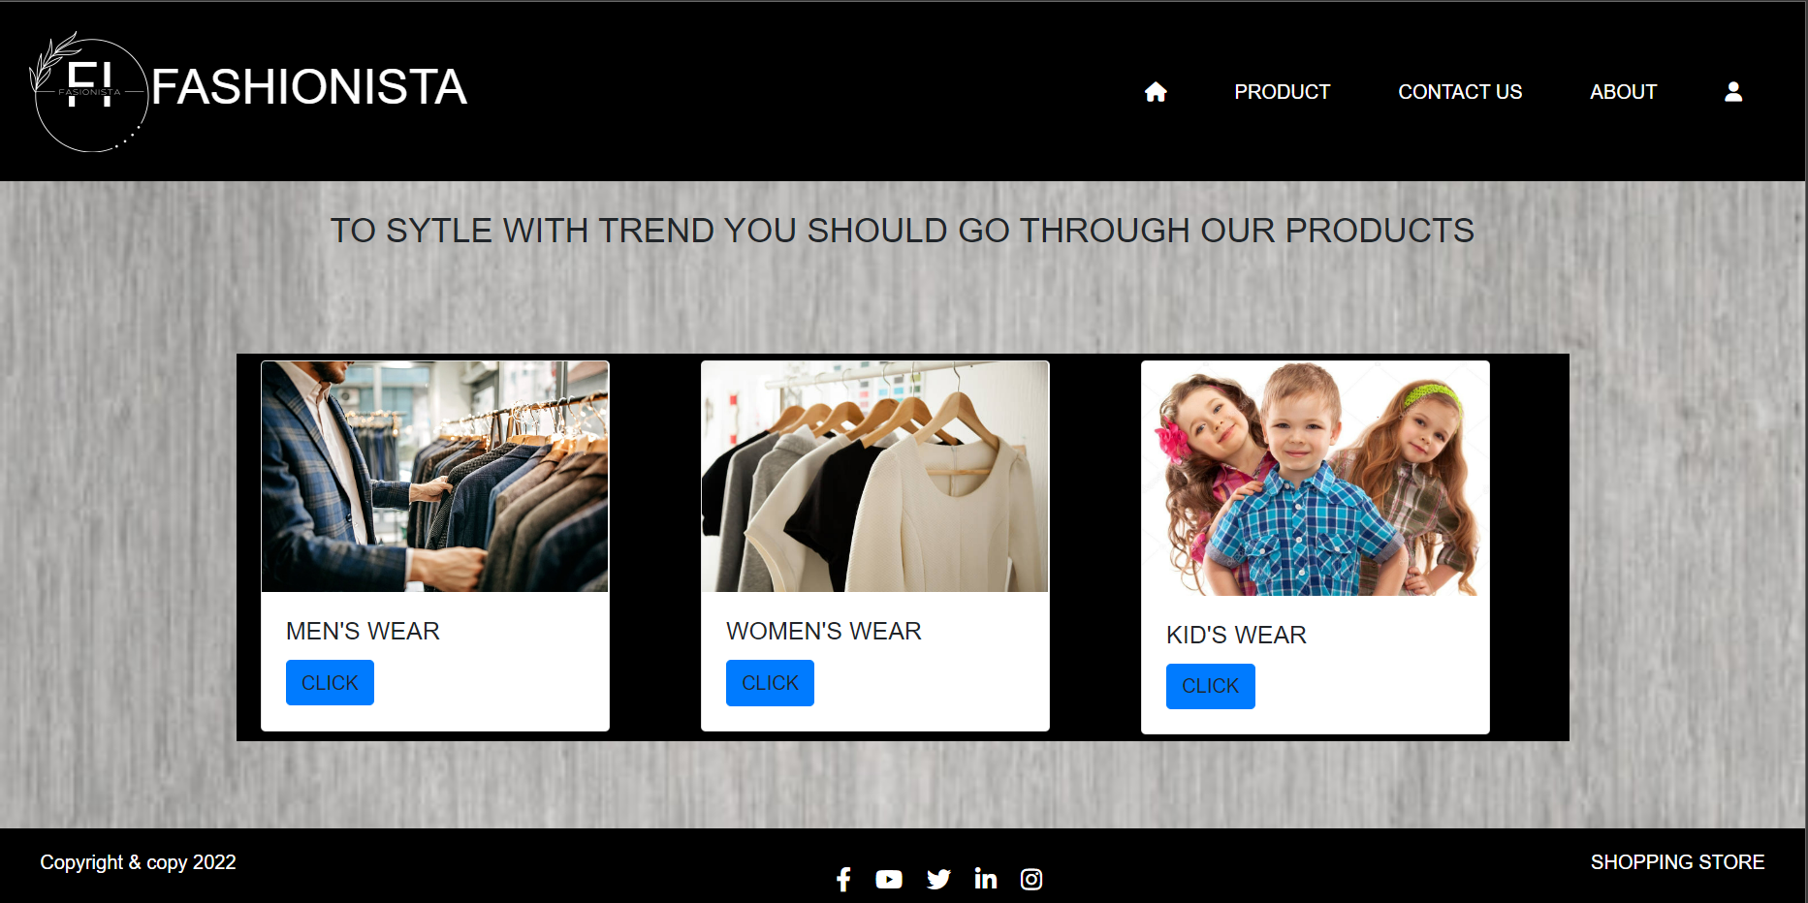

* about.php(with styling)

<!DOCTYPE html>

<html lang="en">

<head>

<meta charset="UTF-8">

<meta http-equiv="X-UA-Compatible" content="IE=edge">

<meta name="viewport" content="width=device-width, initial-scale=1.0">

<title>Document</title>

<style>body {

font-family: Arial, Helvetica, sans-serif;

margin: 0;

}

html {

box-sizing: border-box;

}

*, *:before, *:after {

box-sizing: inherit;

}

.column {

float: left;

width: 25%;

margin-bottom: 16px;

padding: 0 8px;

}

.card {

box-shadow: 0 4px 8px 0 rgba(0, 0, 0, 0.2);

margin: 8px;

}

.about-section {

padding: 50px;

text-align: center;

background-color: #474e5d;

color: white;

}

.container {

padding: 0 16px;

}

.container::after, .row::after {

content: "";

clear: both;

display: table;

}

.title {

color: grey;

}

.button {

border: none;

outline: 0;

display: inline-block;

padding: 8px;

color: white;

background-color: #000;

text-align: center;

cursor: pointer;

width: 100%;

}

.button:hover {

background-color: #555;

}

@media screen and (max-width: 650px) {

.column {

width: 100%;

display: block;

}

}</style>

</head>

<body>

<div class="about-section" id="about">

<h1>About Us </h1>

<p>The FASIONISTA community is here to make you trend with style.</p>

<p>We are here to style you with the trendiest wears our community. We are here making you avail the most trendy clothes ever with good quality. </p>

</div>

<h2 style="text-align:center">Our Team</h2>

<div class="row">

<div class="column">

<div class="card">

<img src="assets/images/me4.jpg" alt="Mike" style="width:100%">

<div class="container">

<h2>Preeti Paryani</h2>

<p class="title">MEMBER</p>

<p>I am desinger of the home page of this site .</p>

<p>preetiparyani29@gmail.com</p>

<p><button class="button">Contact</button></p>

</div>

</div>

</div>

<div class="column">

<div class="card">

<img src="assets/images/a2.png" alt="Mike" style="width:100%">

<div class="container">

<h2>Nishita Gour</h2>

<p class="title">MEMBER</p>

<p>I am a backend language developer of this website. I am here to clear your queries</p>

<p>nishigour@gmail.com</p>

<p><button class="button">Contact</button></p>

</div>

</div>

</div>

<div class="column">

<div class="card">

<img src="assets/images/a3.png" alt="John" style="width:100%">

<div class="container">

<h2>Riya Chouhan</h2>

<p class="title">MEMBER</p>

<p>I am the designer responsible for the trend list here to help with styling here...</p>

<p>riyachouhan@gmail.com</p>

<p><button class="button">Contact</button></p>

</div>

</div>

</div>

<div class="column">

<div class="card">

<img src="assets/images/a4.png" alt="mahi" style="width:100%">

<div class="container">

<h2>Mahima Rathore</h2>

<p class="title">MEMBER</p>

<p>I am the assistant designer here to help with styling here on the behalf of my seniors</p>

<p>mahimarathore@gmail.com</p>

<p><button class="button">Contact</button></p>

</div>

</div>

</div>

</div>

</body>

</html>

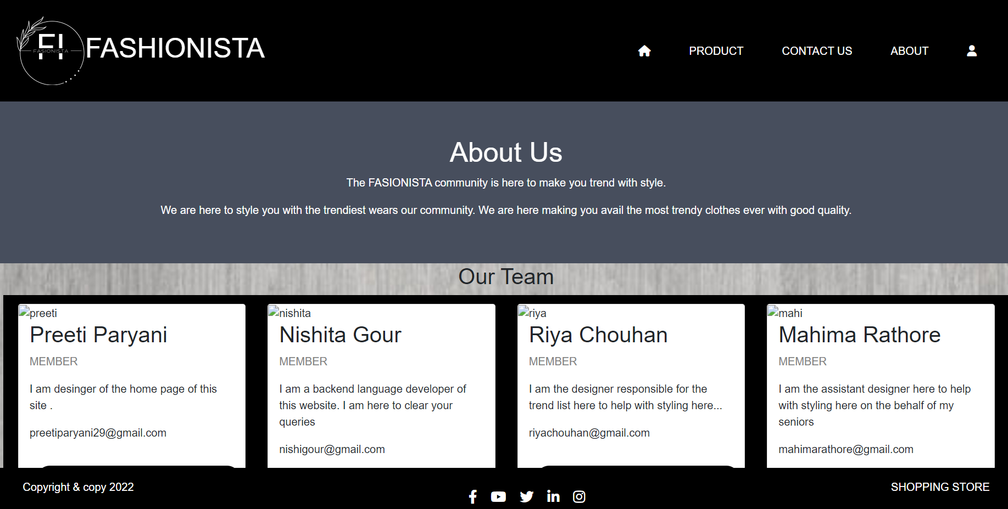

* allproducts.php

<?php

include "config/db.php";

$category = $_GET['type'];

$sql = " SELECT * FROM `product` WHERE `type` = '$category'";

$res = mysqli_query($conn, $sql);

$pageName = "MEN'S PRODUCT";

include 'partials/header.php';

include 'partials/navbar.php';

?>

<div class="container">

<div class="text-center">

<h3>Product List</h3>

</div>

<div class="row">

<?php

while ($row = mysqli_fetch_assoc($res)) {

?>

<div class="col-4">

<div class="card">

<div class="card-header">

<h3><?= $row['name'] ?></h3>

</div>

<div class="card-body">

<img width="50%" height="100px" src="../uploads/<?= $row['image']?>" alt="mlksajfdslkfs" srcset="">

<p>

<b>Price = <?= $row['price'] ?>;</b>

</p>

<!-- <h3>

Category = <?= $row['type'] ?>

</h3> -->

<a class="click btn" href="buynow.php">

<button type="button" class="btn btn-warning">

BUY NOW

</button>

</a>

</div>

</div>

</div>

</div>

</div>

<?php

include 'partials/footer.php';

include './config/db.php';

?>

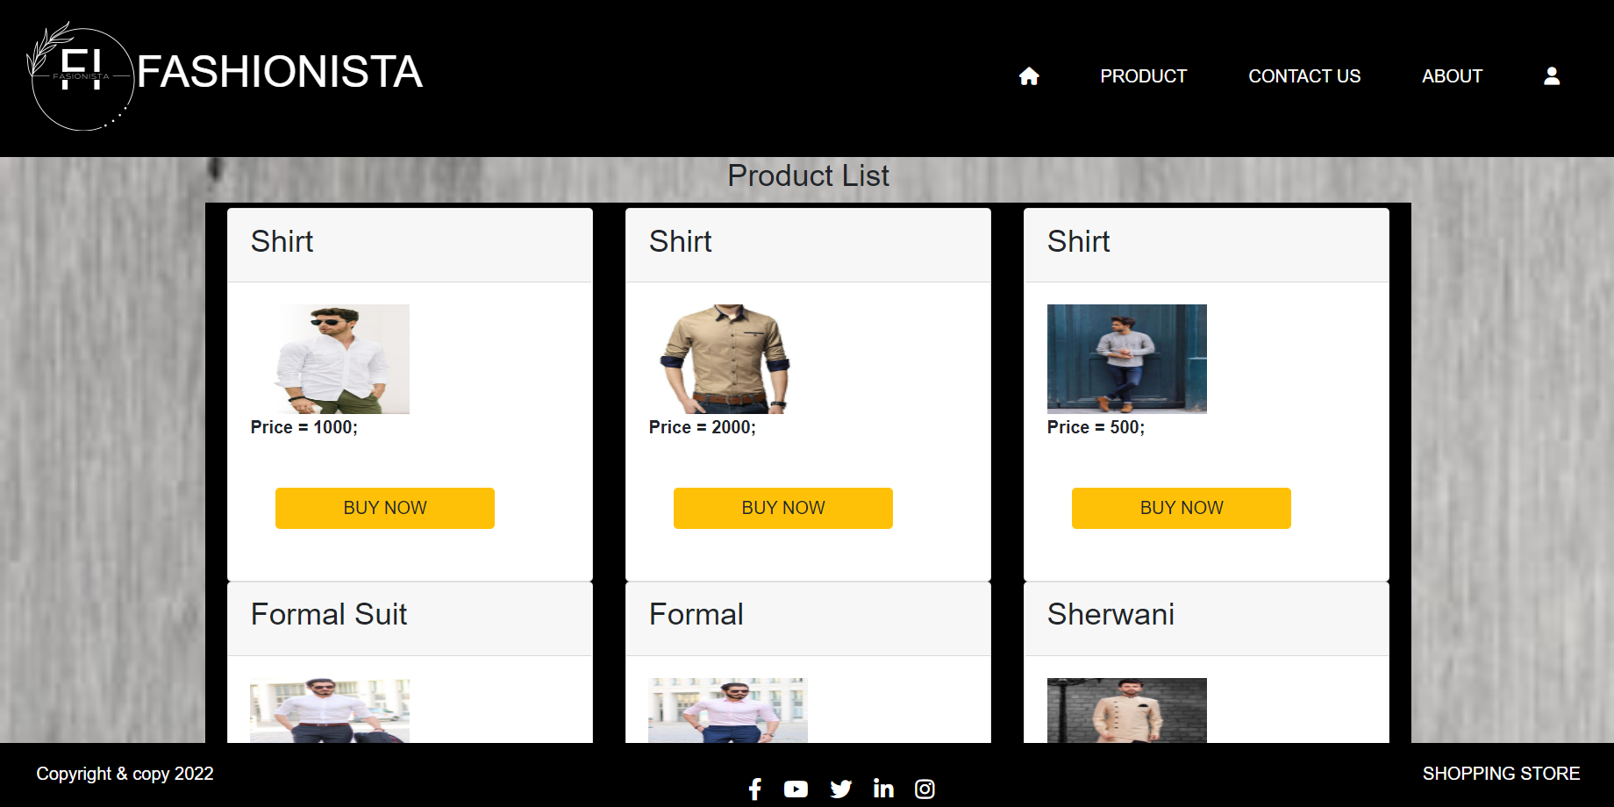

**7. Conclusion:**

The project entitled Online shopping system was completed successfully.

The system has been developed with much care and free of errors and at the same time it is efficient and less time consuming. The purpose of this project was to develop a web application and an android application for purchasing items from a shop. This project helped us in gaining valuable information and practical knowledge on several topics like designing web pages using html & css, usage of responsive templates, designing of android applications, and management of database using mysql . The entire system is secured. Also the project helped us understanding about the development phases of a project and software development life cycle. We learned how to test different features of a project. This project has given us great satisfaction in having designed an application which can be implemented to any nearby shops or branded shops selling various kinds of products by simple modifications. There is a scope for further development in our project to a great extend. A number of features can be added to this system in future like providing admin more control over products so that each moderator can maintain their own products. Another feature we wished to implement was providing classes for customers so that different offers can be given to each class. System may keep track of history of purchases of each customer and provide suggestions based on their history. These features could have implemented unless the time did not limited us.